HUSSEINI SULEIMAN
2025/FWSD/11478
fwsd2511478@students.icdfa.edu.ng
DATE: 4TH September, 2026
COURSE CODE: SBT-DF202 · Practical Laboratories

Lab 3 — Data Carving with XXD, Binwalk and Scalpel
Submit before 05 Sep 2026, 4:20 PM WAT.

Scenario

Your practical context
A forensic storage image contains files that may no longer be recoverable through normal file-system browsing. Some file metadata may be missing, damaged, or unreliable. Acting as a junior digital forensic analyst, you are required to examine raw file content, identify file signatures, recover embedded content, and carve deleted files from a USB forensic image while documenting every step in a repeatable forensic manner.
Objectives

What you must demonstrate
By completing this lab, students will demonstrate their ability to explain why data carving is required when file-system metadata is missing or unreliable; use xxd to examine binary file content and identify headers and footers; recognise JPEG SOI and EOI signatures; reconstruct binary content from a hexadecimal dump; use The Sleuth Kit to examine inode, block and sector-level data; identify and extract embedded content using Binwalk; recover deleted files from a forensic USB image using Scalpel; verify recovered evidence using cryptographic hashes; and prepare a professional forensic report containing commands, screenshots, findings and limitations.
Instructor briefing

Laboratory guidance
Before beginning this lab, review the Module 7 lessons and study material on Data Carving and File Recovery Techniques. The lecture material is already a detailed walkthrough, so you are expected to understand file signatures, hexadecimal analysis, embedded-file recovery and carving concepts before executing commands.
Create a dedicated working directory and preserve all downloaded evidence files. Record MD5 and SHA-256 hashes before beginning analysis.

Required Lab Resources
Download the authorised training evidence below:
- Ch01InChap01.dd — Forensic DD Image
- J_ub_law.jpg — JPEG Sample for Hex and Signature Analysis
- 120M.7z — USB Image for Scalpel File Carving
These are the exact evidence resources identified in the lab guide.
The display image when the command (J_ub_law.jpg) was inputed
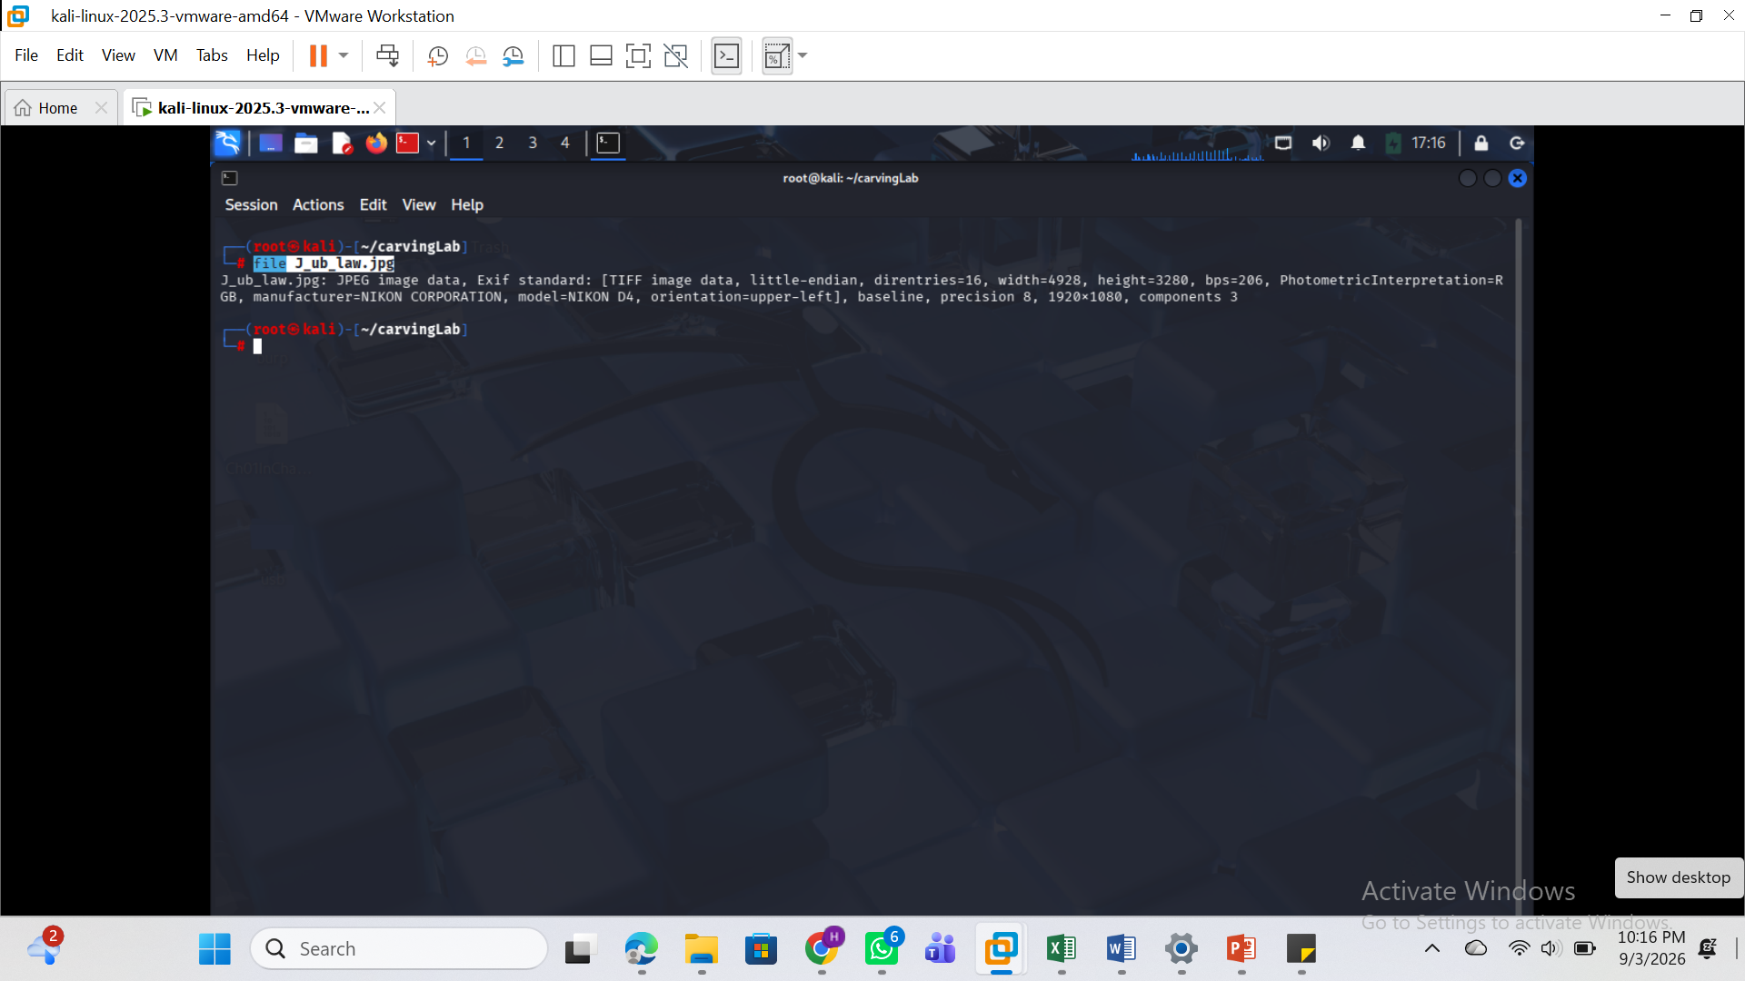

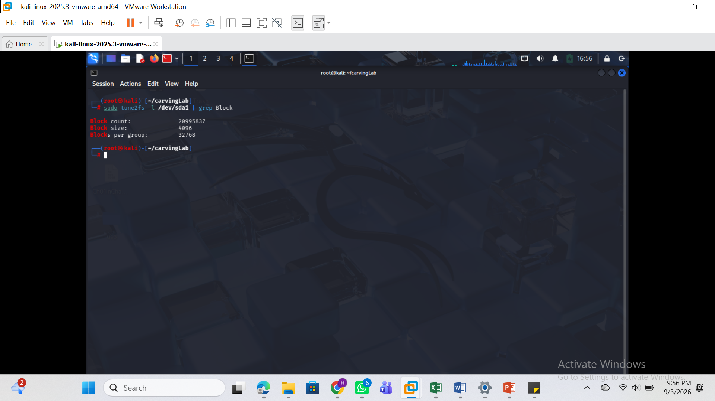
See the display image when the command is used: display J_ub_law.jpg

See the image info when the command (file J_ub_law.jpg) is used

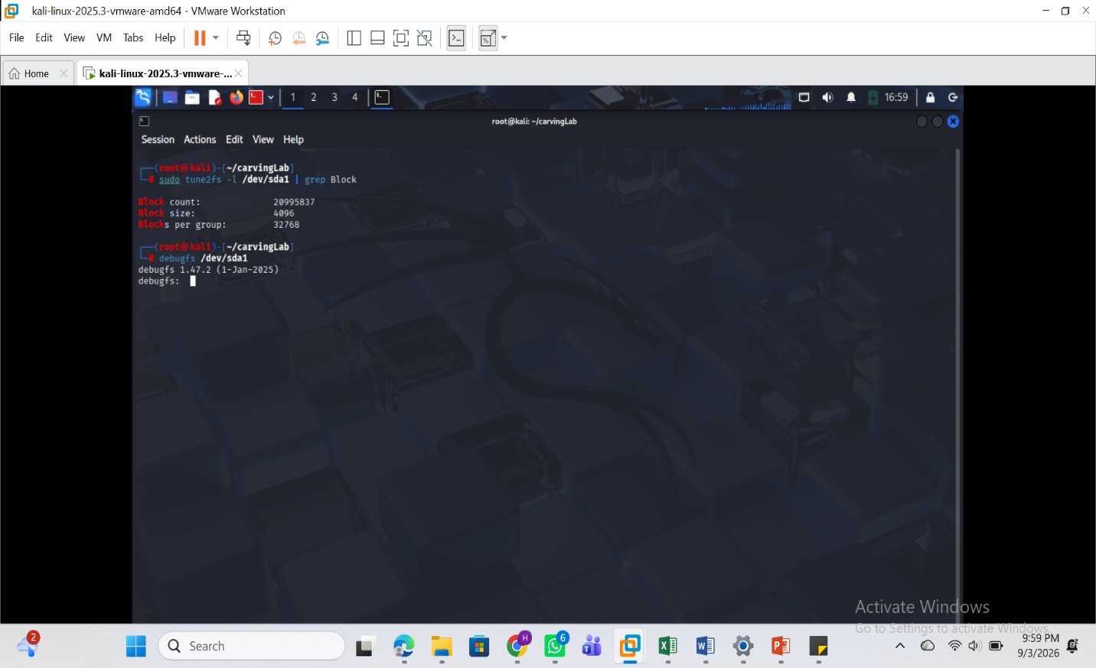
Using the command (ls J_ub_law.jpg –l) see the permissions and the lab environment preparation.

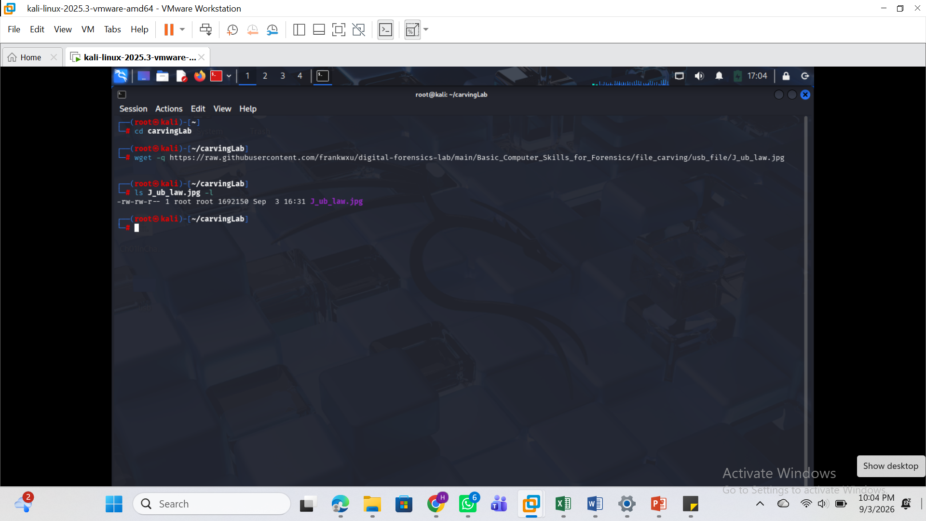
Using xxd to inspect J_ub_law.jpg, identify the JPEG header and footer signatures, create a plain hexadecimal dump, and reconstruct the image using reverse-hexdump functionality.
Using the command: xxd J_ub_law.jpg| head
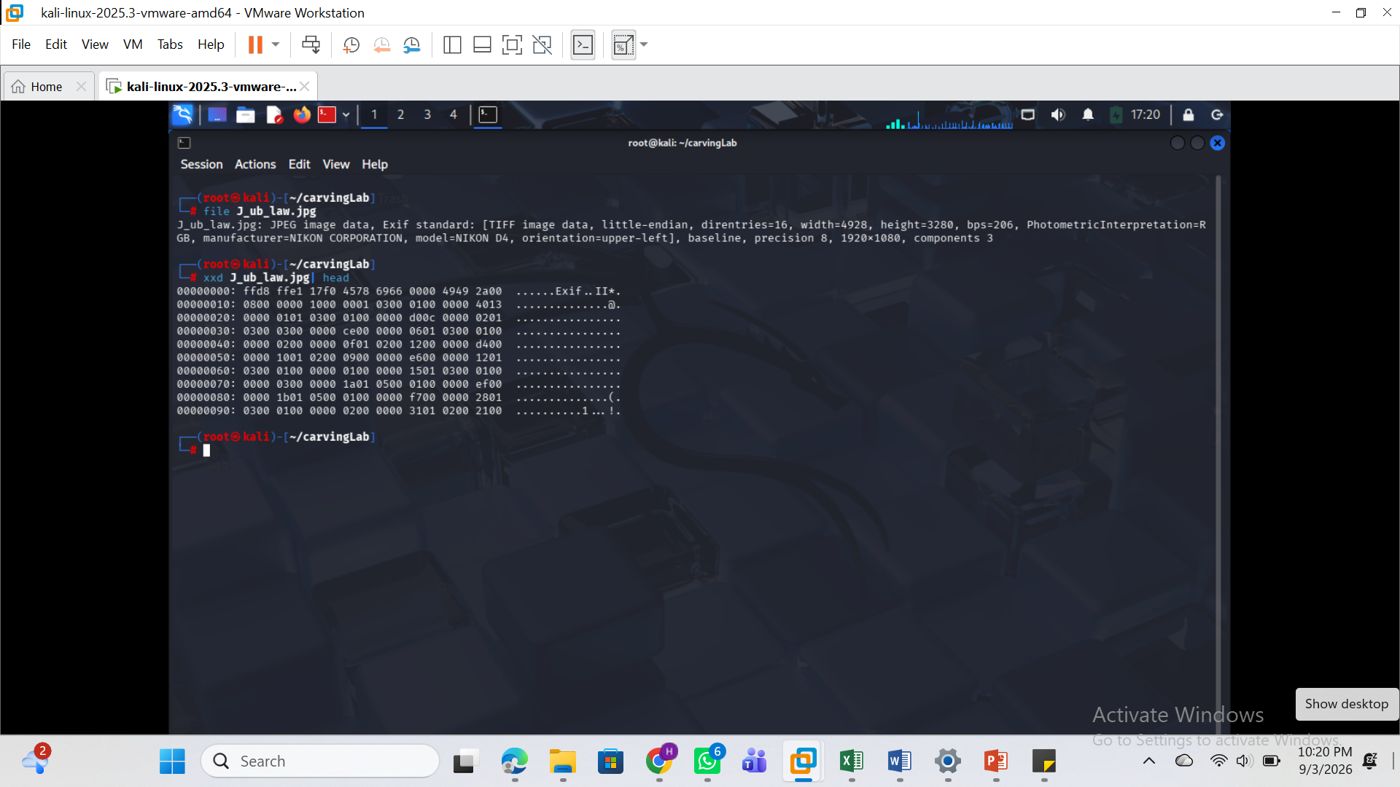
Command to show the tail of the picture: xxd J_ub_law.jpg| tail -n 2
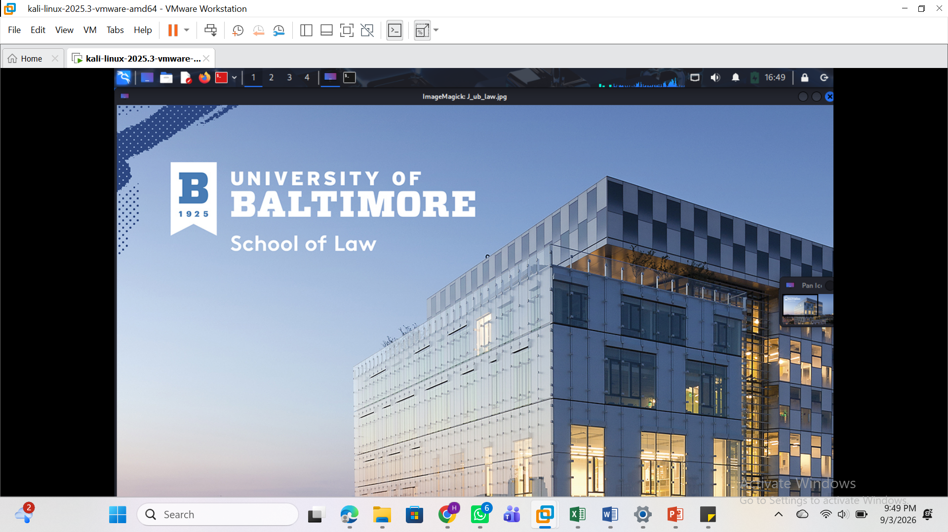

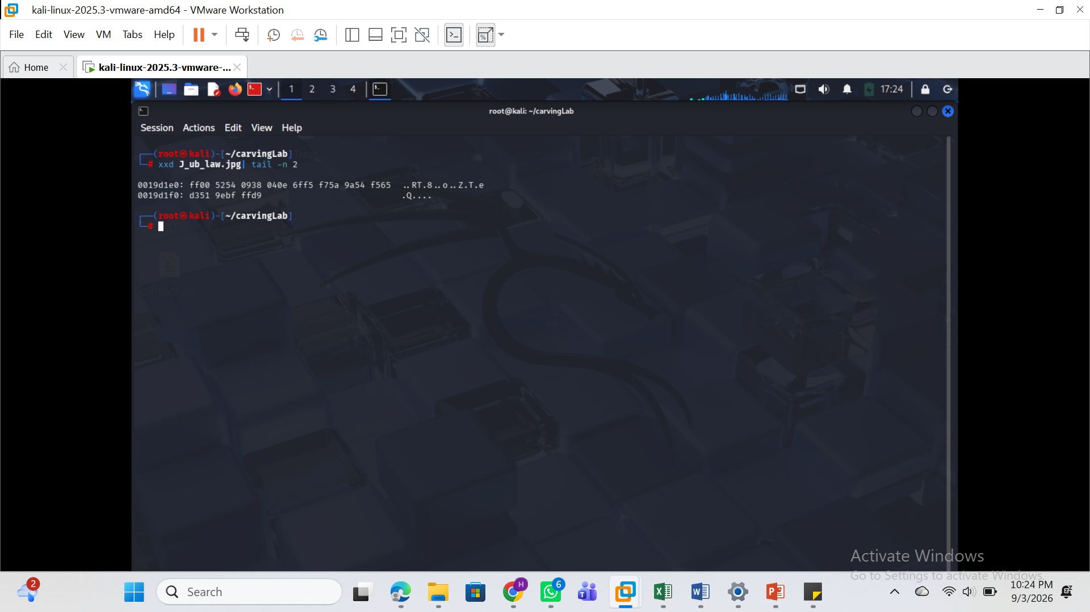

Using the command: xxd -l 120 J_ub_law.jpg
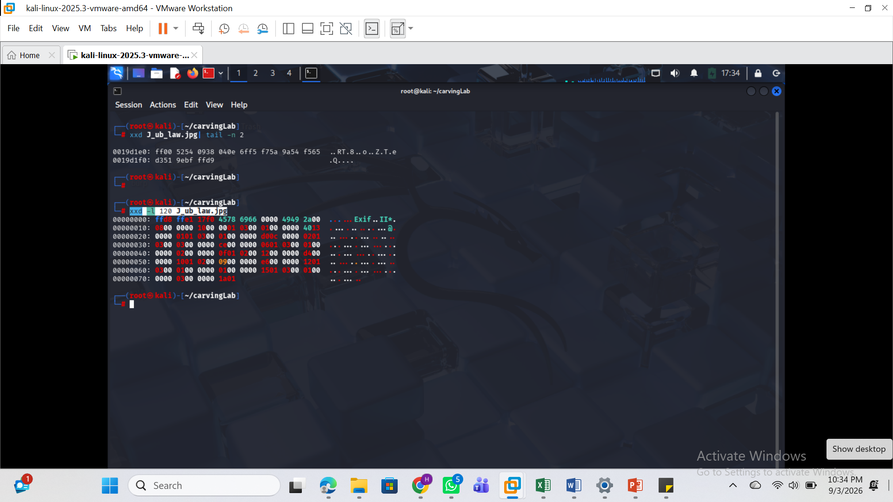

Using the command: xxd -s 0X19d1f0 J_ub_law.jpg
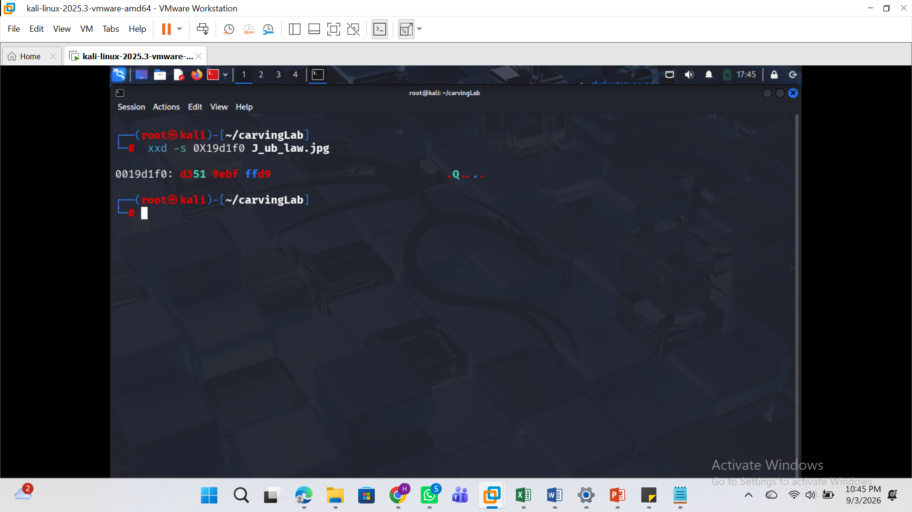

Using the commands to Search signatures in plain hexdump
: xxd J_ub_law.jpg| head -5
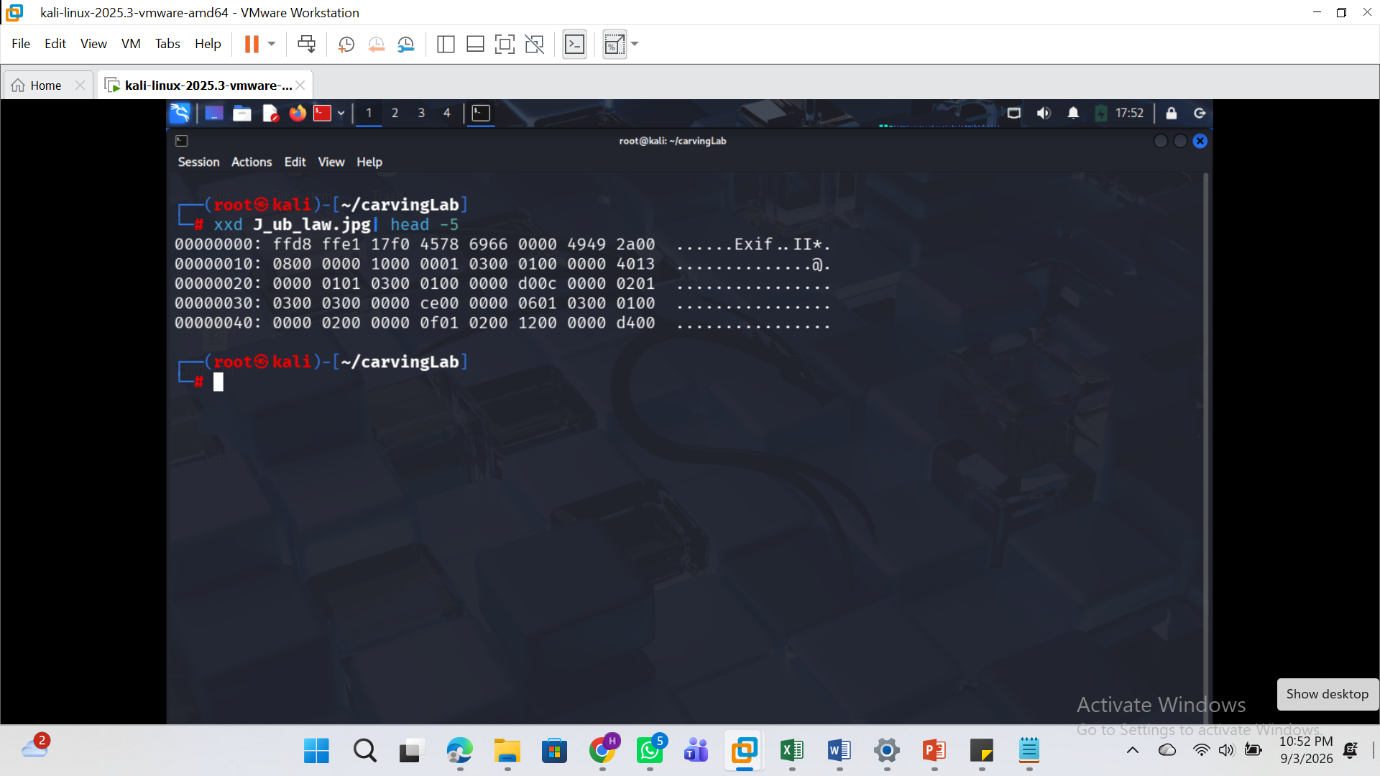

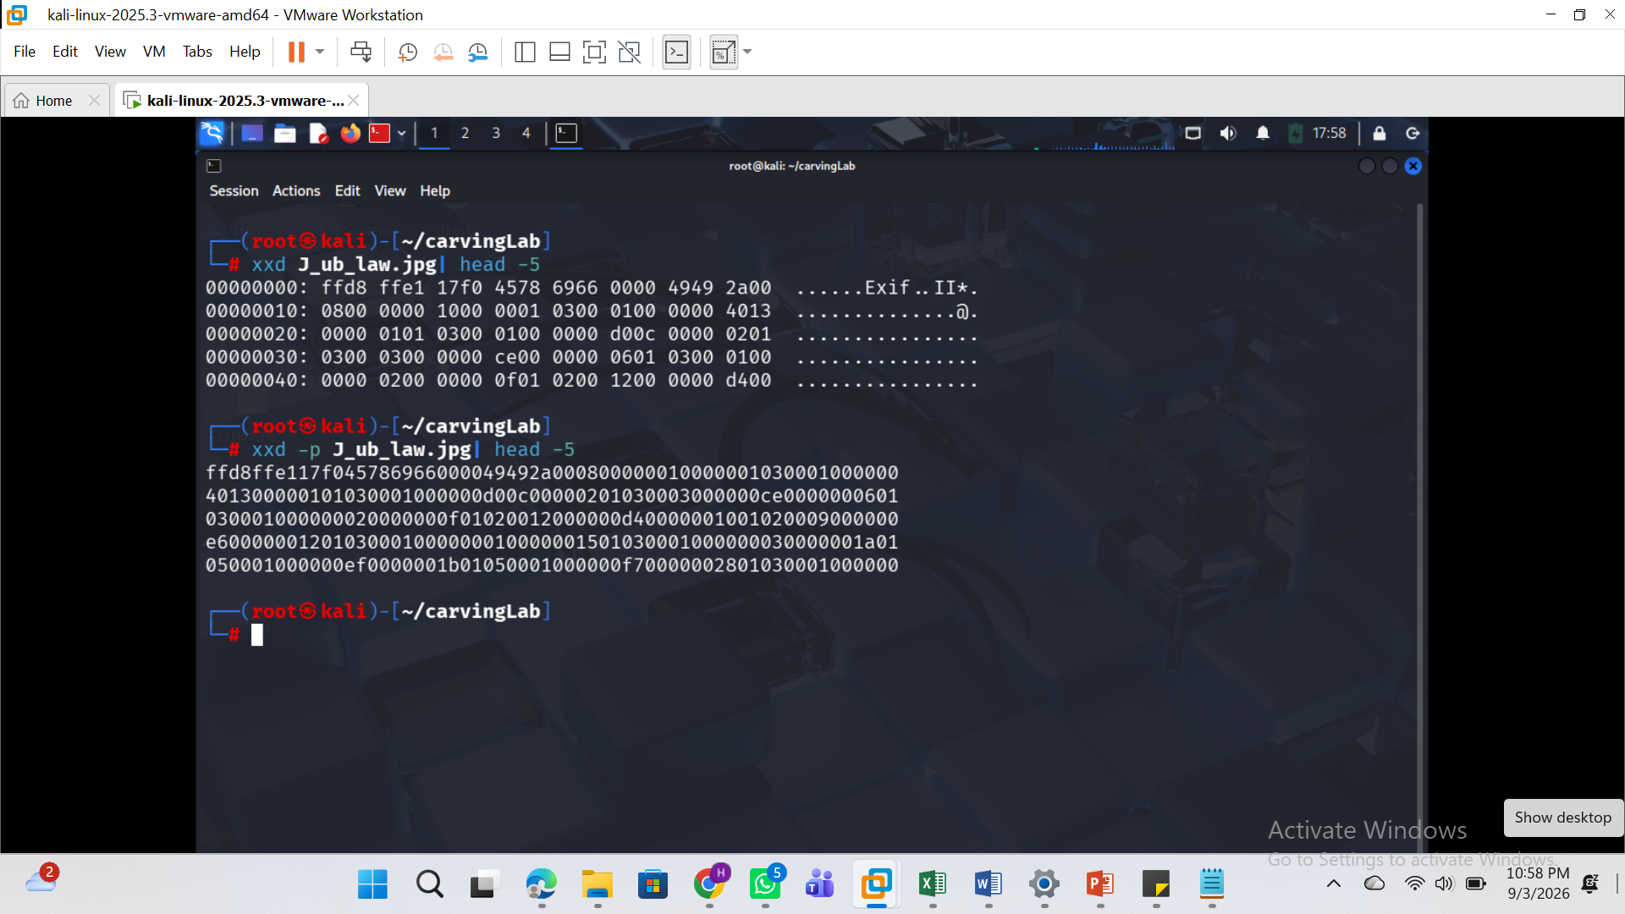
Search header in plain hexdump using the command: xxd -p J_ub_law.jpg | grep -i "ffd8ffe1"

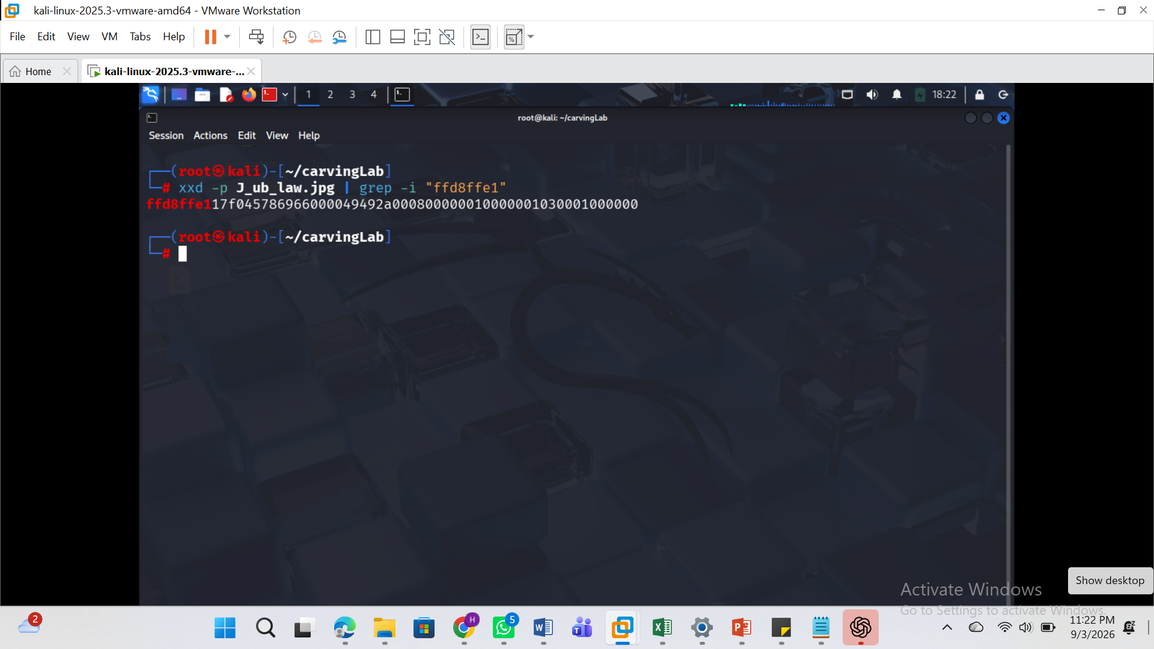

xxd J_ub_law.jpg | tail | grep -i "ffd9"

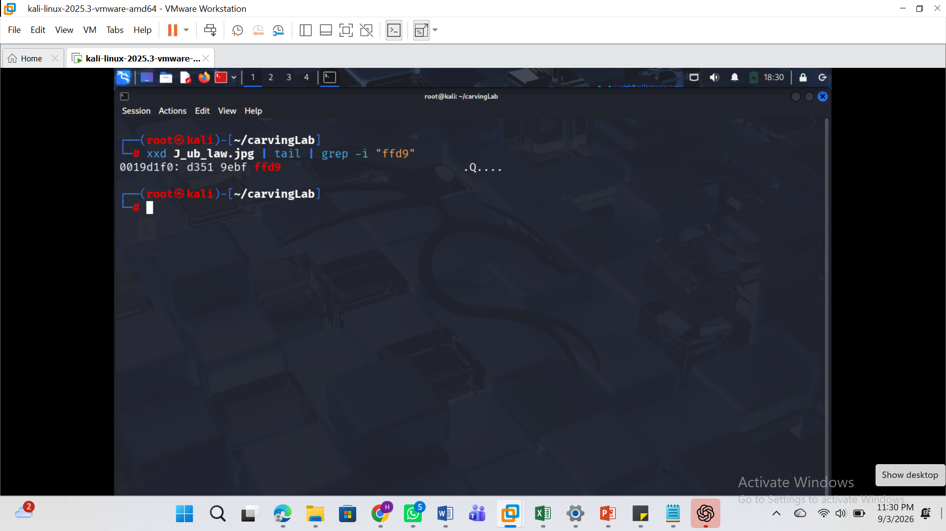

Using the command: xxd J_ub_law.jpg | head -5
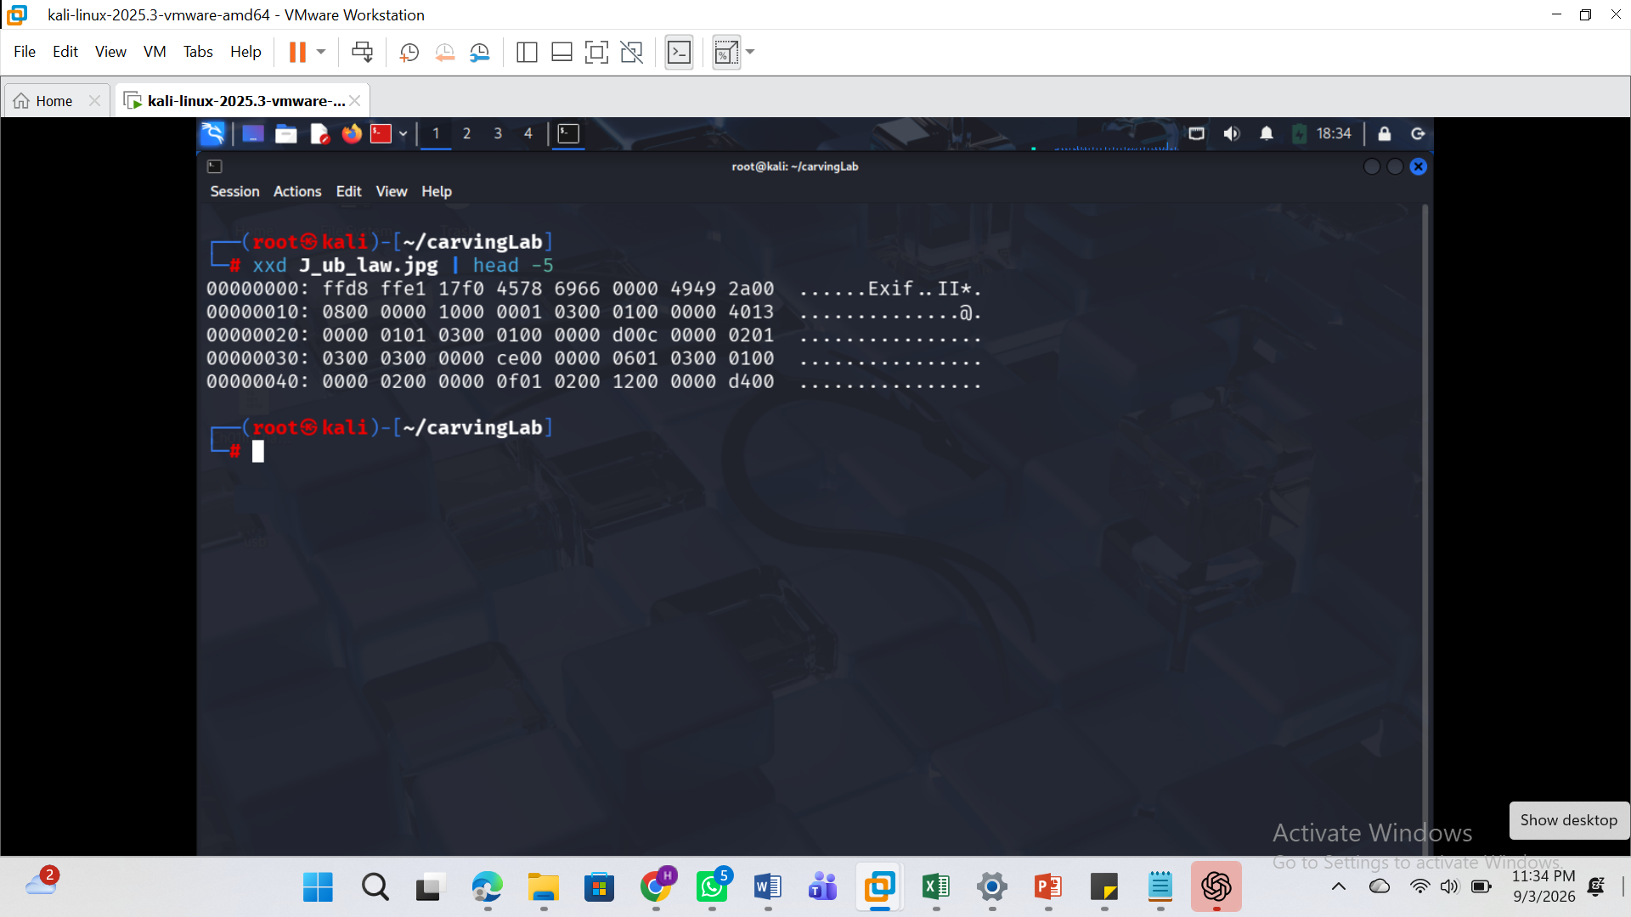
Using the command: xxd -p J_ub_law.jpg | tr -d "\n"| more
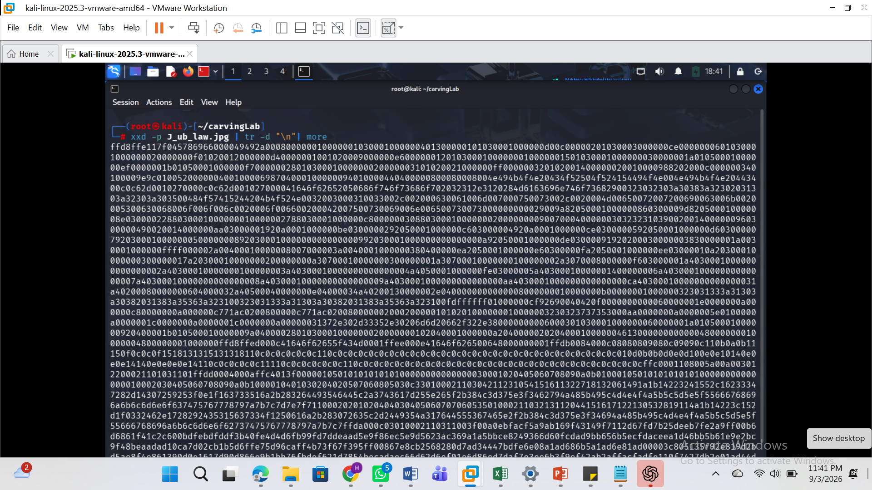

Convert a plain hexdump to back into binary
See the command used: xxd -r -p J_ub_law_hexdump.txt J_ub_law_reverse_dum.jpg
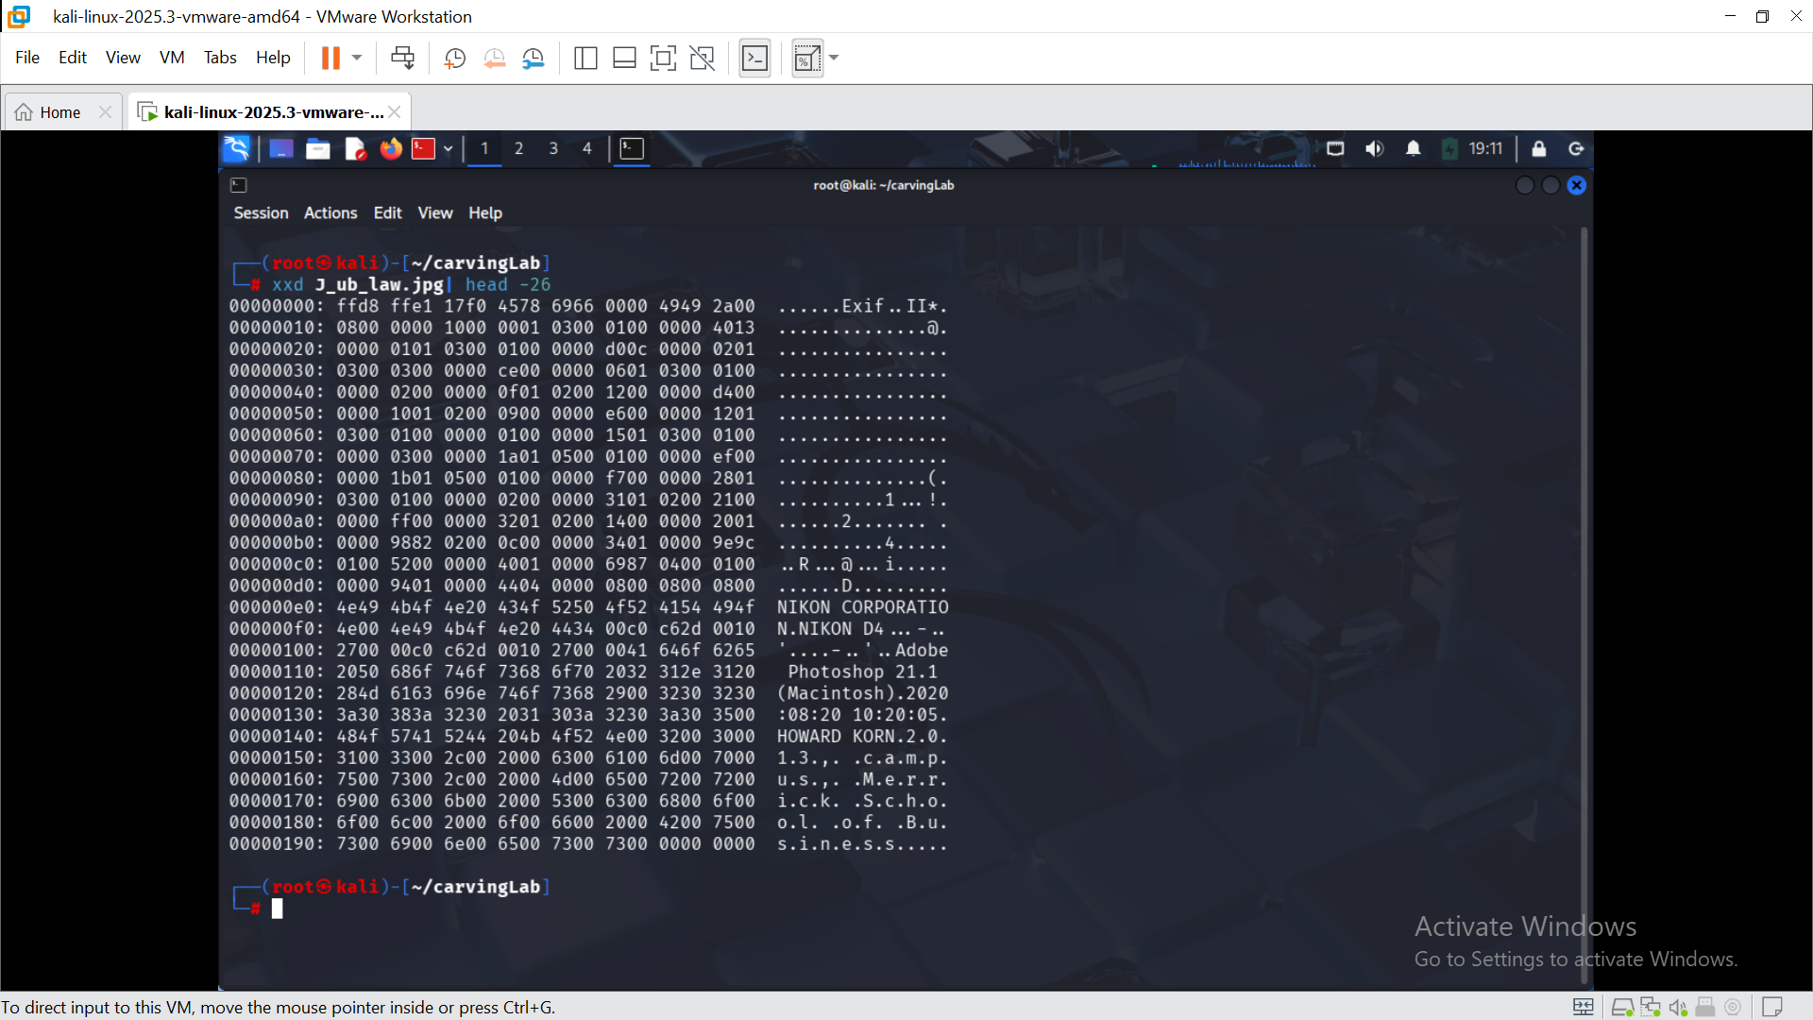
xxd -s 0x100 -l 0x9f J_ub_law.jpg

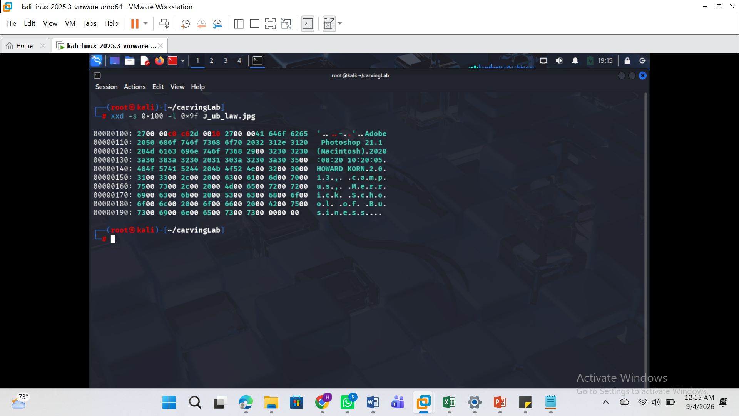
Using: xxd -s 0x140 -l 11 J_ub_law.jpg
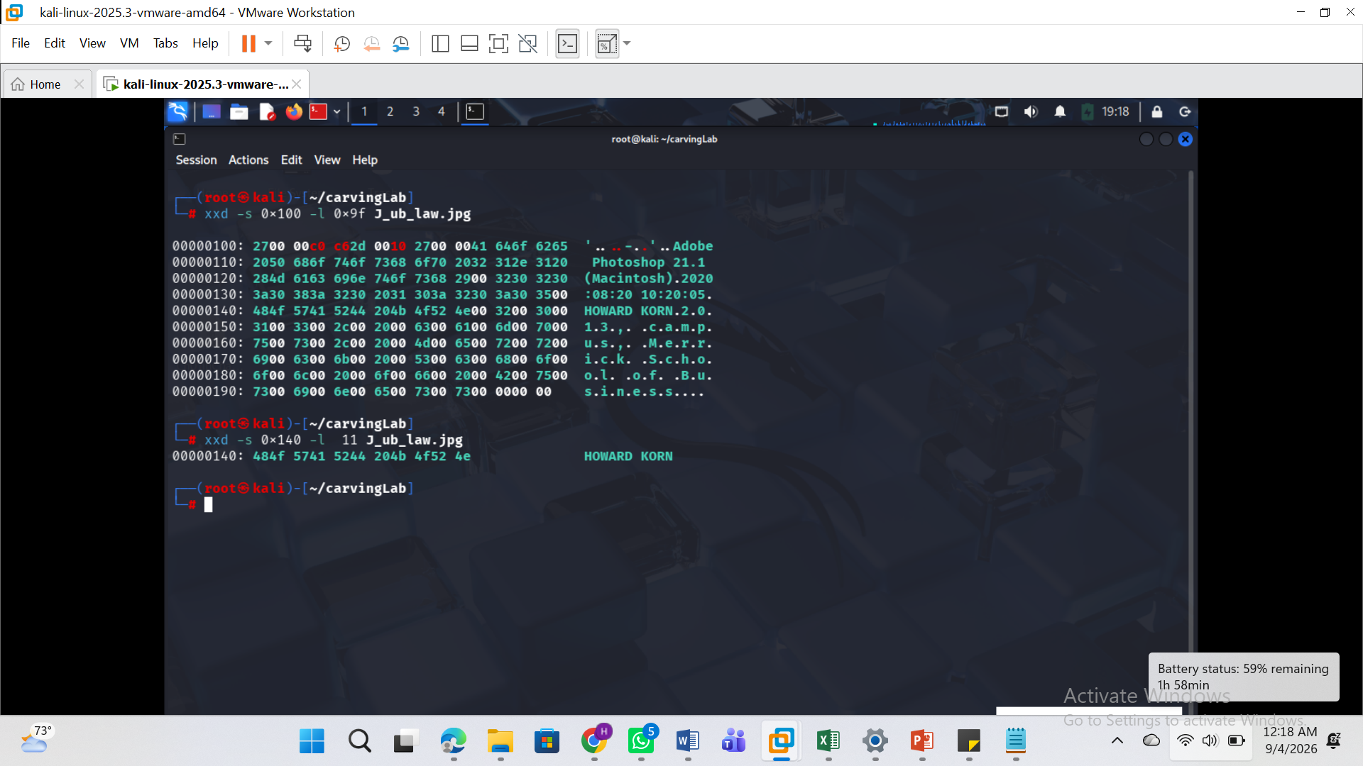

Verifying the reconstructed image by comparing MD5 and SHA-256 hashes with the original
Command used: ls -l 120M.7z showing the root kali permissions
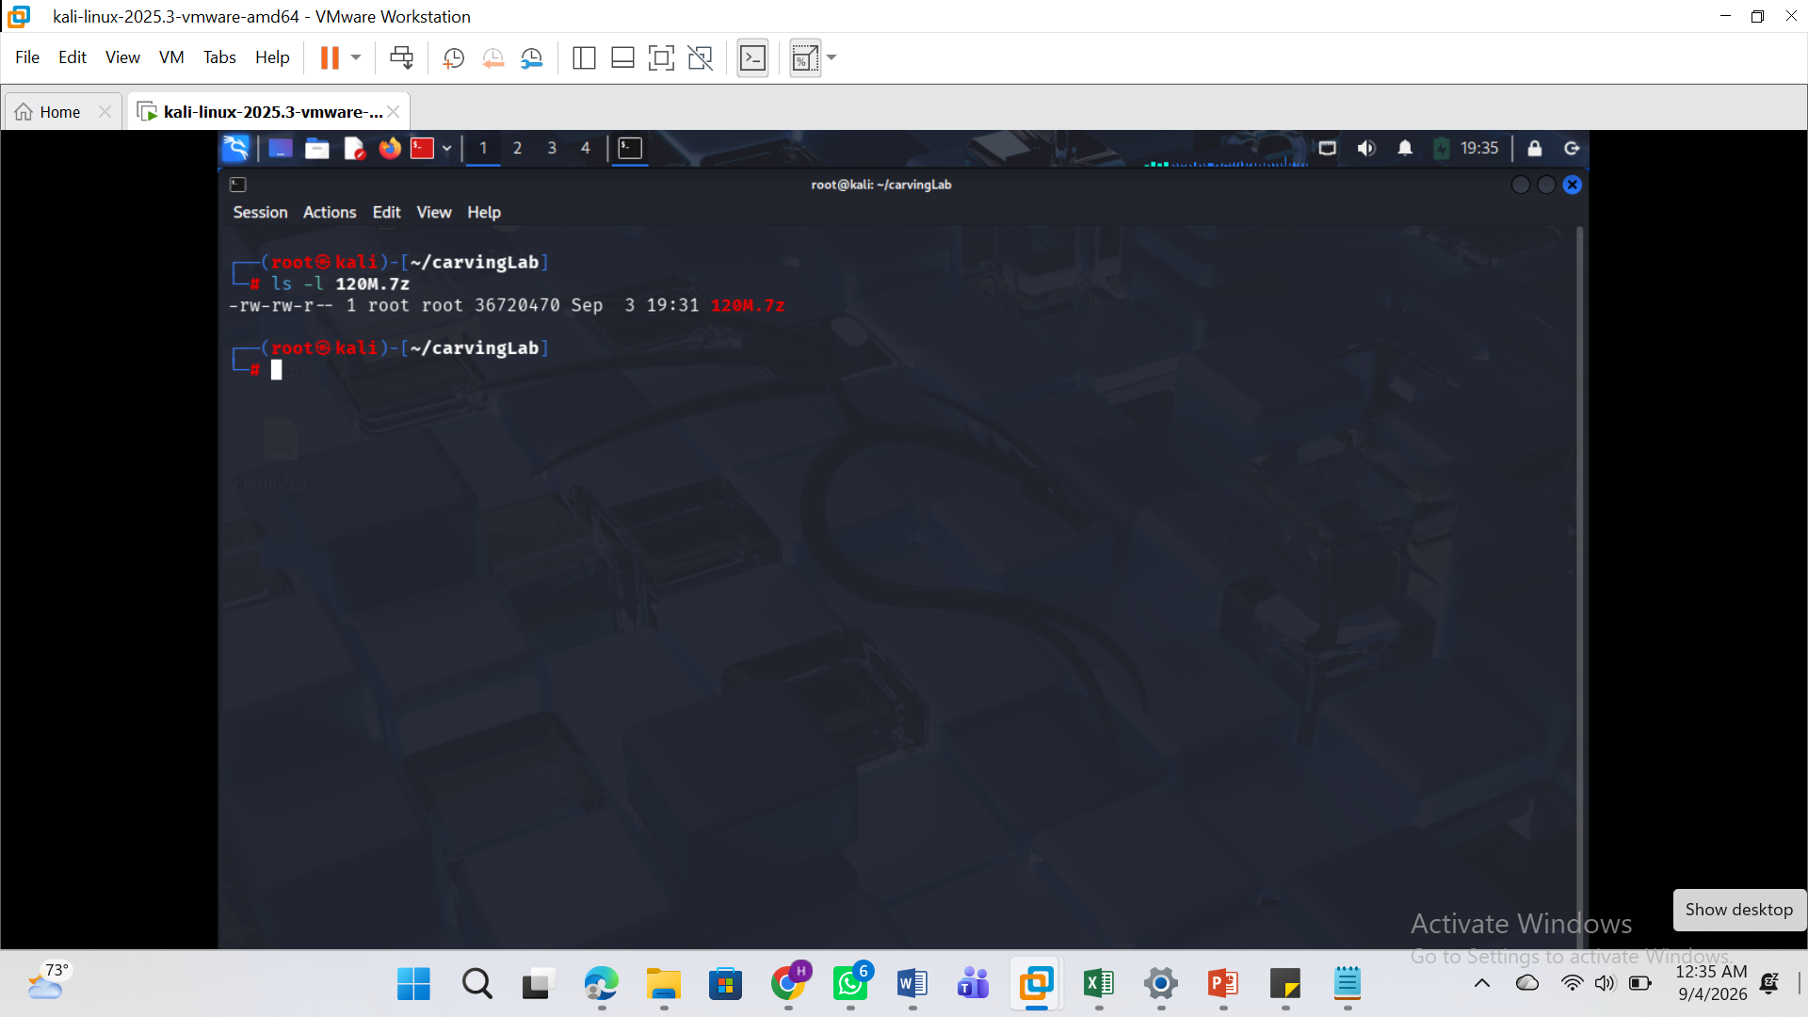
comparing MD5 and SHA-256 hashes with the original
see attach and the command used: hashdeep -c md5,sha1 120M.7zclear
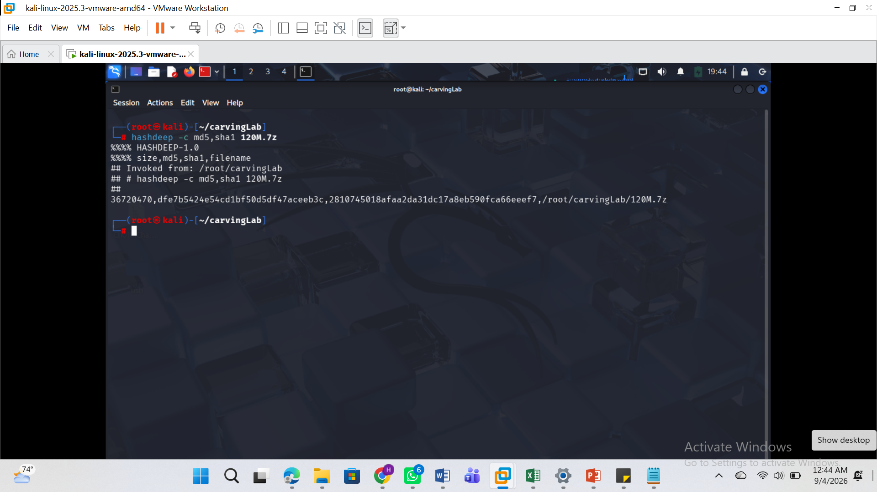
Listing the content of the zip file using the command: 7z l 120M.7z
See output below
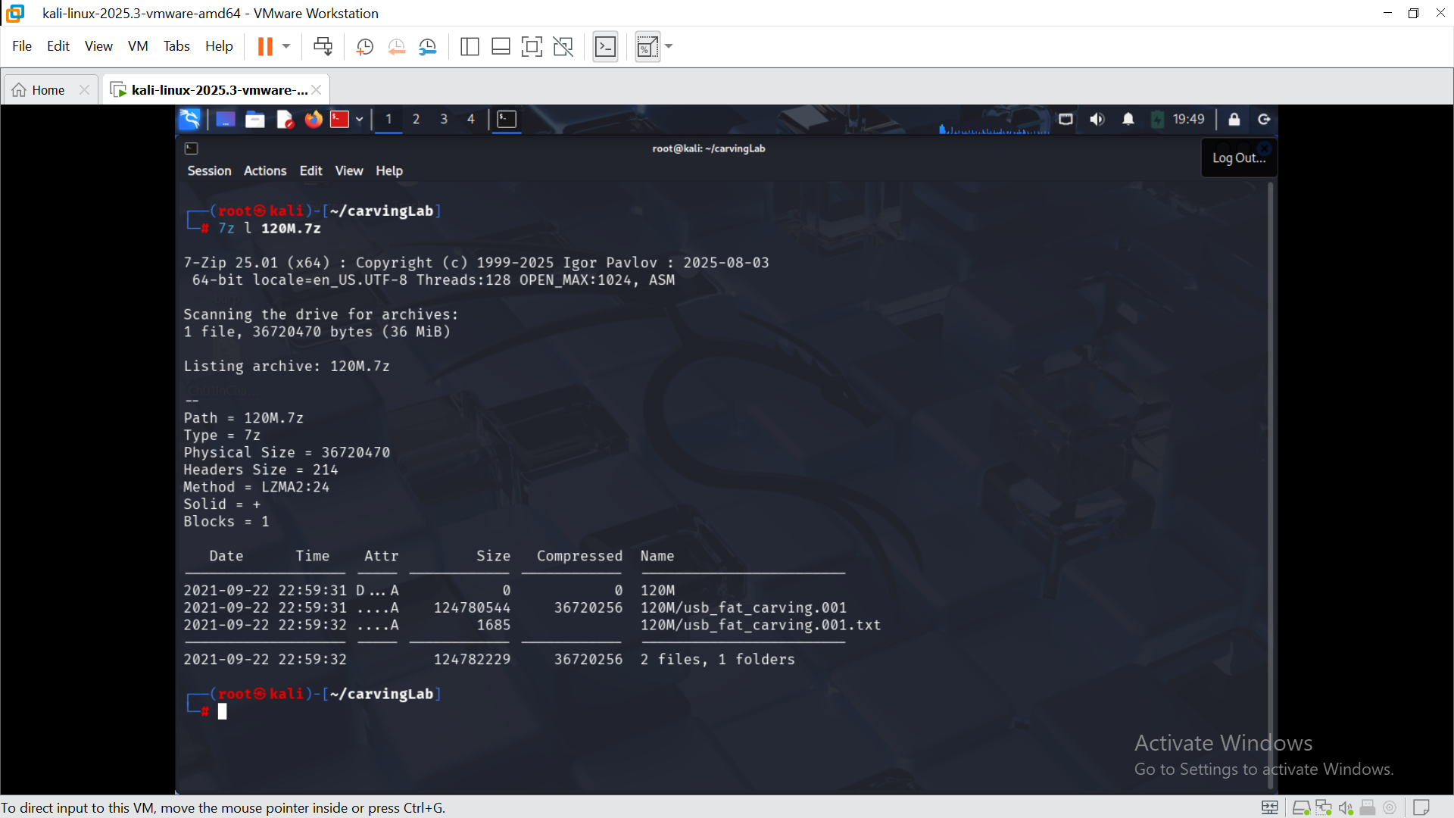
7z e 120M.7z
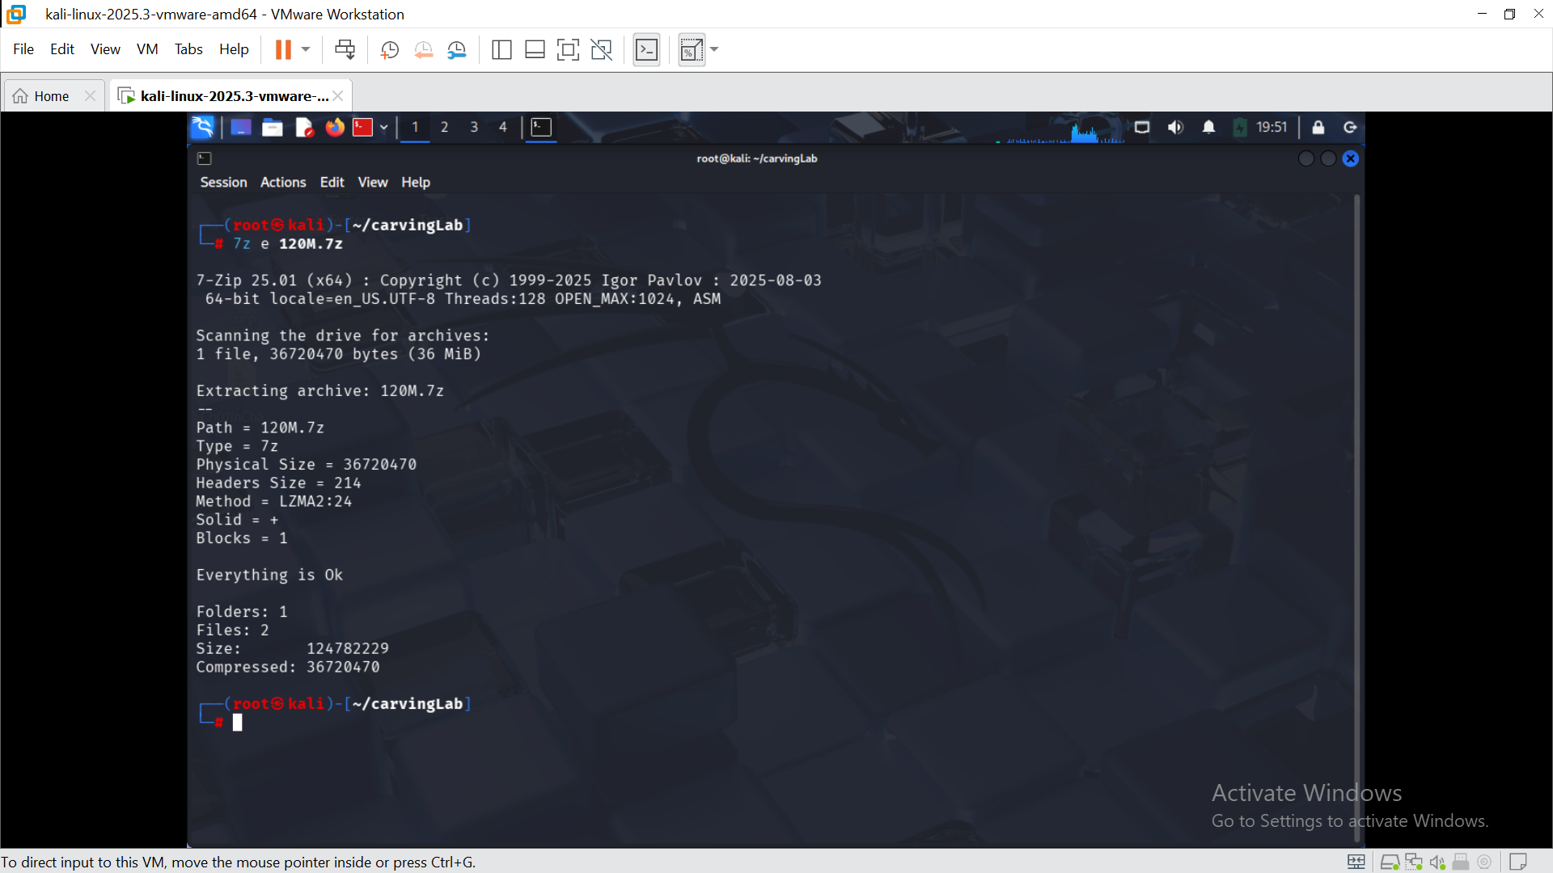
hashdeep -c md5,sha1 120M.7z usb fat carving.001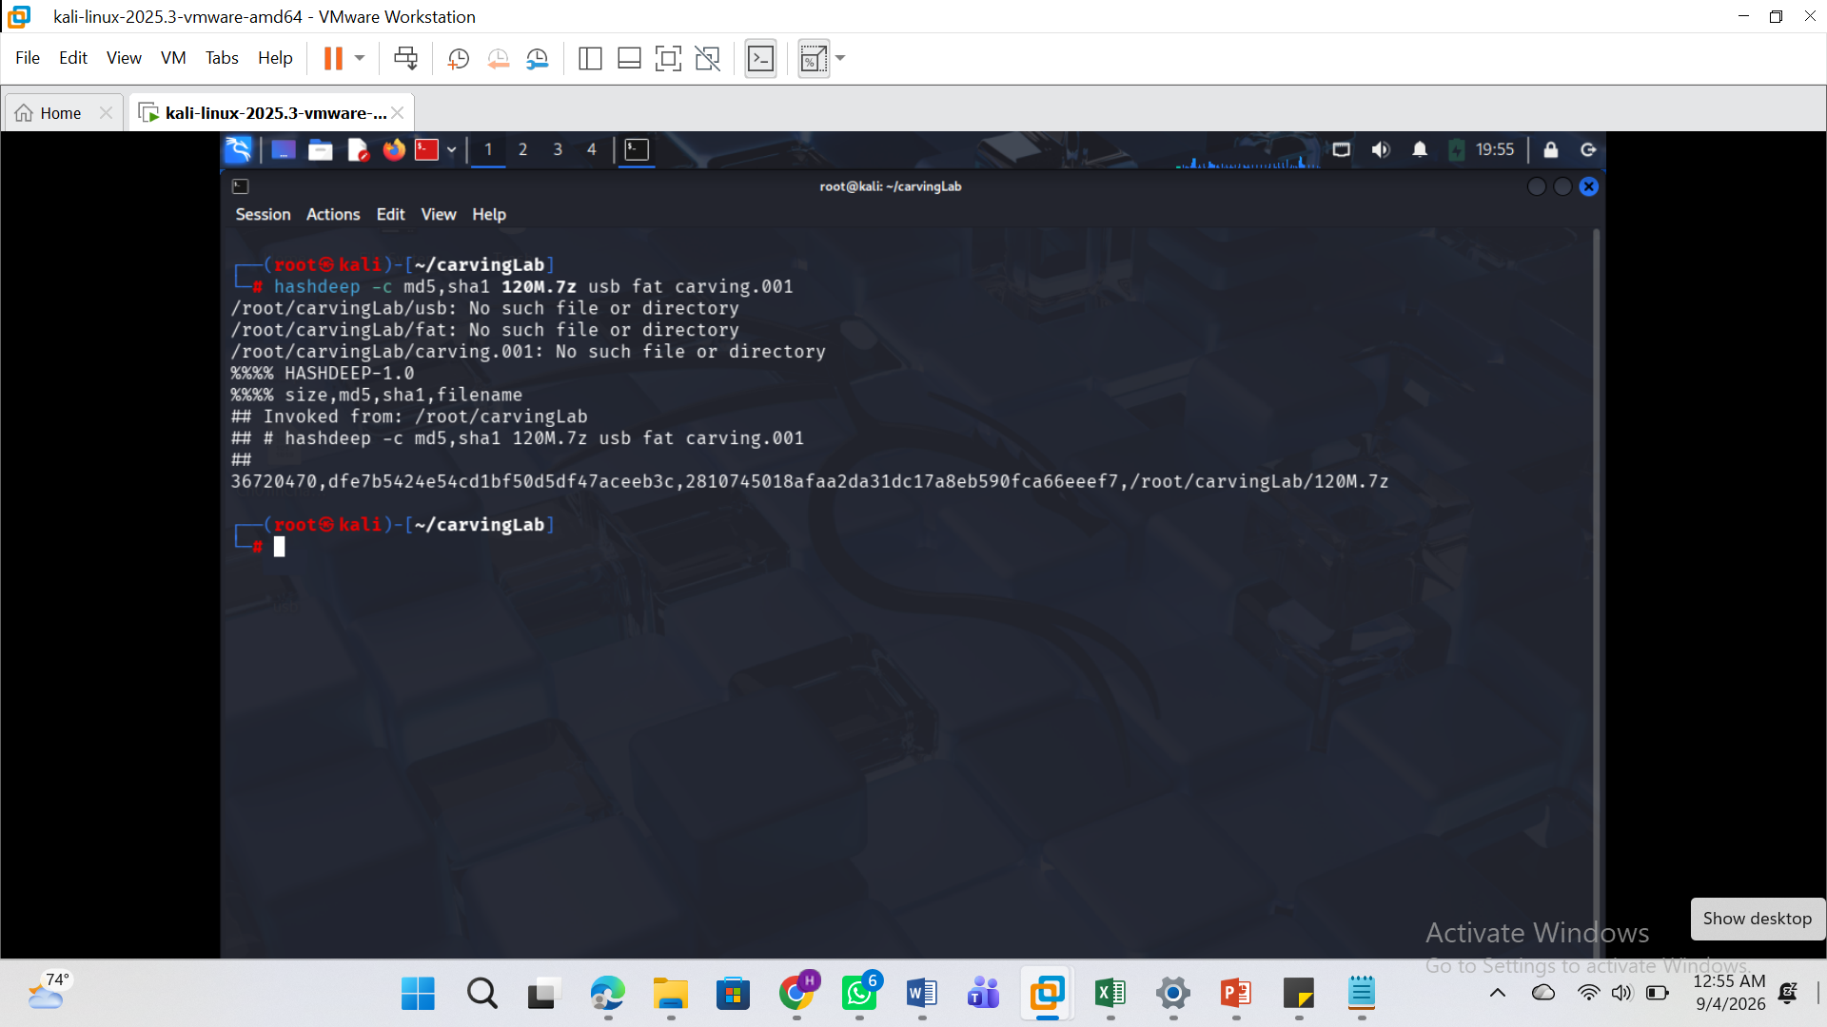

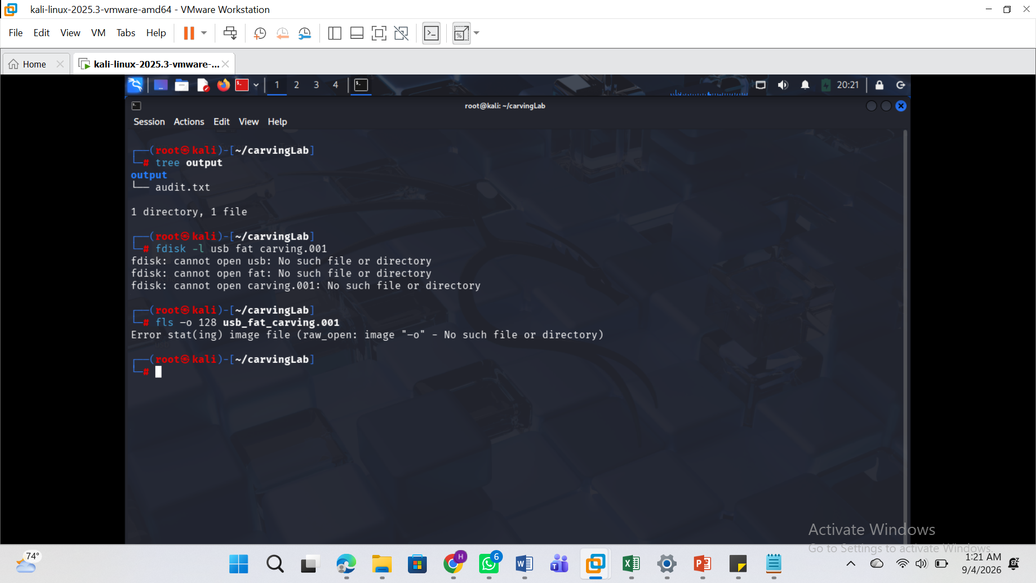
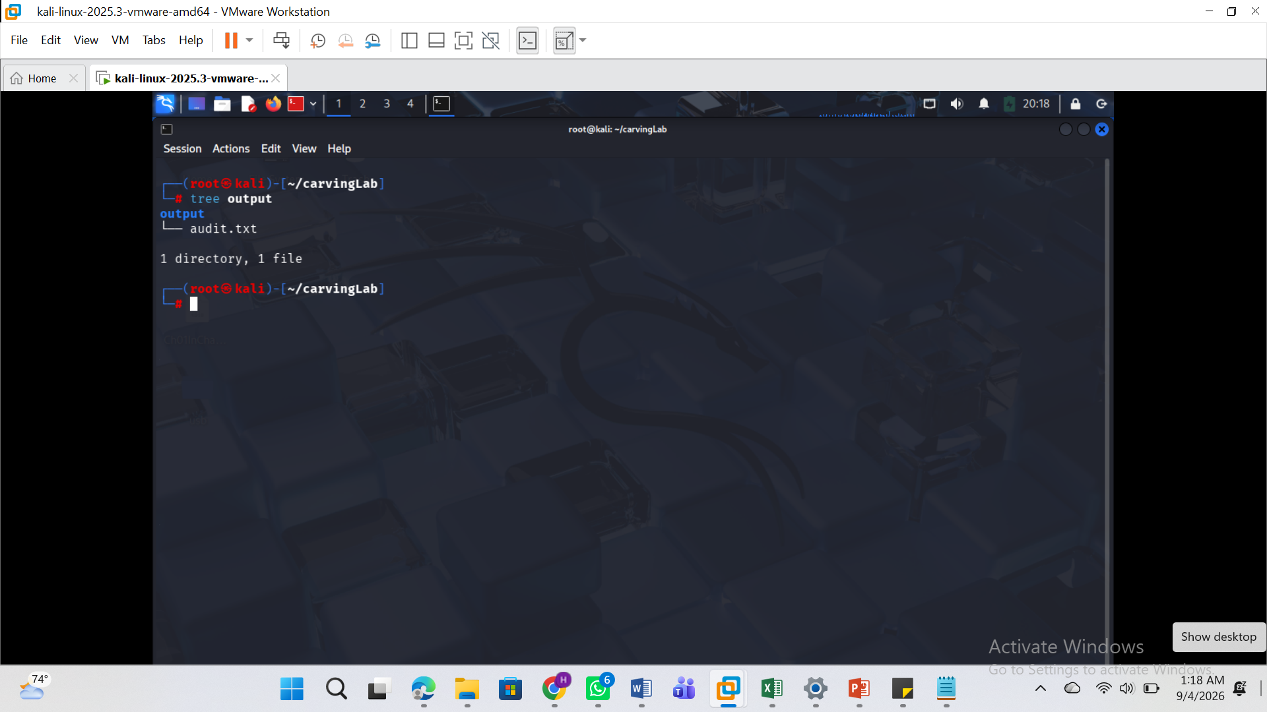
cat output/audit.txt
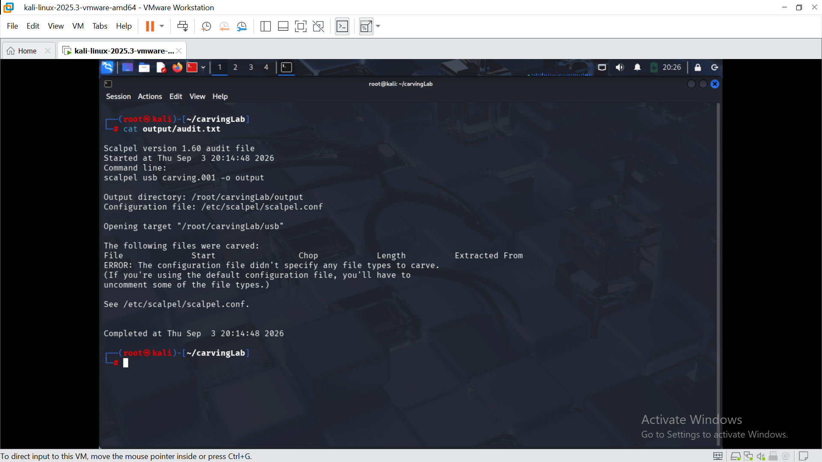

Part B - Examine Embedded Metadata-Like Content
Use xxd and strings to inspect the JPEG for visible camera, software, name, date or other metadata-related strings.
Record only information actually found. If a searched item is not present, state “not found” rather than guessing.

Part C - Direct Data-Unit Examination with The Sleuth Kit
Use tools such as:
img_stat
mmls
fsstat
fls
icat
blkcat
Identify actual inode and sector/block values from your own command output. Do not copy placeholder values from examples.

Part D - Embedded File Discovery with Binwalk
Use binwalk to identify embedded file structures or signatures.
If the instructor-provided File_carving.docx is available, perform the demonstrated manual and automatic extraction workflow. If it is not available, document this limitation and complete the Binwalk practice using the other supplied lab evidence.

Part E - Prepare the USB Image
Extract 120M.7z, identify the resulting USB image, calculate hashes, inspect the image using TSK, and confirm the appropriate partition offset using mmls.
The source lab refers to an offset of 128, but students must confirm the partition structure rather than blindly copying the value.

Part F - Carve Deleted Files with Scalpel
Configure Scalpel to enable the required file types, particularly JPEG/JPG, and run the carving operation against the forensic USB image.
Review:
- Recovered files
- File types
- Hashes
- audit.txt
- At least two recovered JPEG images where available
Document every command, result, screenshot, recovered artefact, error and limitation.
Do not modify the original evidence files.
Required evidence
Submit one professional PDF forensic report and one ZIP archive containing the required recovered/carved evidence files, hash records and supporting output.
Required evidence must include:
Proof that the Module 7 material was reviewed before starting.
Working directory and downloaded evidence files with file sizes and hashes.
xxd output showing JPEG header and footer analysis.
Reverse-hexdump reconstruction and hash comparison.
strings or metadata-style examination of the sample JPEG.
TSK mmls / fls and related data-unit analysis output.
Scalpel configuration, execution output and audit.txt.
At least two recovered JPEG files opened successfully, or clear evidence explaining why they could not be opened.
Lab access notesThis practical forms part of the second laboratory assessment window. Students must review the Module 7 lessons and study material before beginning. Use only the authorised training files provided in the lab instructions. Preserve the original evidence, record hashes, document all commands and submit both the required PDF report and supporting evidence archive.

